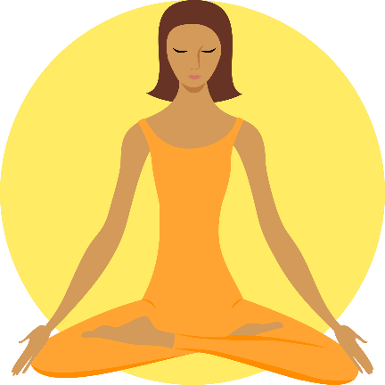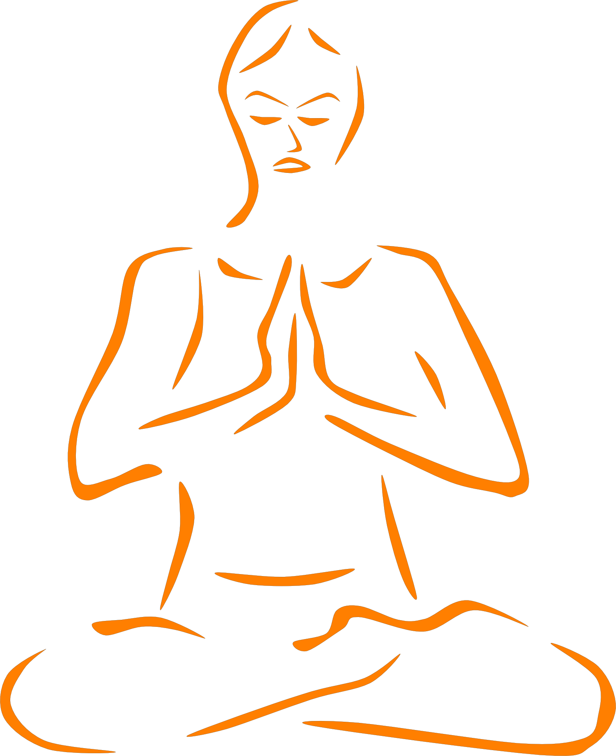

**Meditation for Metacognition**

Questions I would ask about meditation…

Words I associate  
with meditation…  
(Spider-diagram)

**Rank the benefits of meditation from 1 to 10,   
with 1 being the most important or valuable benefit.**

Using meditation we can study thought directly and learn important things about it.

The more we practice meditation the more difficult it is to be distracted.

Meditation makes us more resilient: we can handle difficult emotions better.

By emptying and stilling my mind, I can focus better and listen more attentively in class.

By reducing mental clutter it is easier to remember things that are shared in class.

Because it is relaxing, meditation brings physical health benefits.

Mediation enhances   
self-awareness.

Meditation allows us to understand the relationship between thoughts and emotions

Meditation allows us to train and improve our concentration and focus over time.

Meditation helps to reduce stress and anxiety.

**Match the key-words with their definitions!**

Meditation allows us to study our thoughts directly, in the present moment, as they arise and pass.

In some ways, meditation is the ultimate tool for metacognition as it can help us develop greater concentration and mental discipline. It also helps us to relate to our emotions in a healthy way and reduce stress.

**Mindfulness**

The action or power of focusing all one's attention and awareness on something

The process of reducing anxiety and calming   
the mind.

**Meditation**

Accurate and deep understanding of higher truths and/or internal processes

**Emotional Regulation**

The use of mental disciplines and practices to calm, clarify and focus the mind.

**Introspection**

**Stress  
Reduction**

Focussing on the present moment and not getting   
lost in thought.

**Concentration**

Training the mind and regaining full control of it.

**Insight & Wisdom**

The ability to control one’s emotions through mental and cognitive discipline

**Mental Discipline**

The examination or observation of one's own mental and emotional processes.

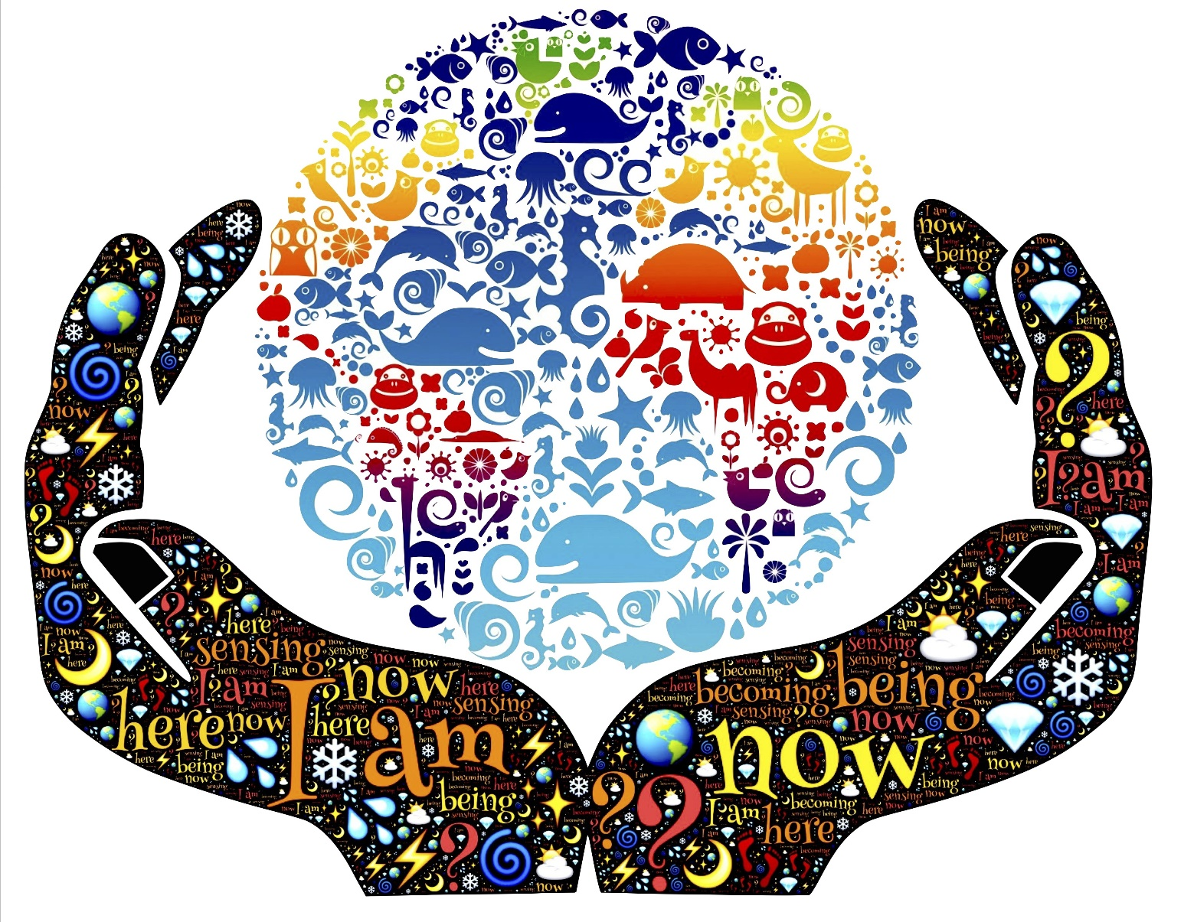

For me, the main benefit of meditation would be…

To meditate, all you need to do with your mind is…

When meditating my posture should be…

The ideal place to meditate is…

**My Meditation Instructions**

Fold and glue this section  
neatly into your exercise book

How to Meditate  
(Mind-Map)

1. Read the text to the right and underline/highlight key phrases in it.
2. Capture important details in a mind-map below.
3. Summarise the text by writing your own meditation instructions below: write as if you are explaining it to a person much younger than you.

This text outlines two different approaches to meditation: mindfulness meditation and concentration meditation. Concentration meditation is good if you want to boost your ability to focus over time whilst mindfulness is more useful as a general way of studying and disciplining the mind, thought and emotion.

When we meditate we should be sit upright and alert whilst allowing the body to relax. Instead of closing your eyes completely (which might make you sleepy) it is good to have your eyes half-closed and gently cast down towards the ground. You should meditate in a quiet room and remove distractions.

Concentration meditation involves focusing on a single point. This could entail following the breath, repeating a single word or mantra, staring at a candle flame, listening to a repetitive gong, or counting beads on a mala. Since focusing the mind is challenging, a beginner might meditate for only a few minutes and then work up to longer durations. In this form of meditation, you simply refocus your awareness on the chosen object of attention each time you notice your mind wandering. Rather than pursuing random thoughts, you simply let them go. Through this process, your ability to concentrate improves.

Mindfulness meditation encourages the practitioner to observe wandering thoughts as they drift through the mind. The intention is not to get involved with the thoughts or to judge them, but simply to be aware of each mental note as it arises. Through mindfulness meditation, you can see how your thoughts and feelings tend to move in particular patterns. Over time, you can become more aware of the human tendency to quickly judge an experience as good or bad, pleasant or unpleasant. With practice, an inner balance develops. In order to benefit from meditation it is important that you practice regularly: ideally you can bring the mind of meditation into every moment of your daily life!