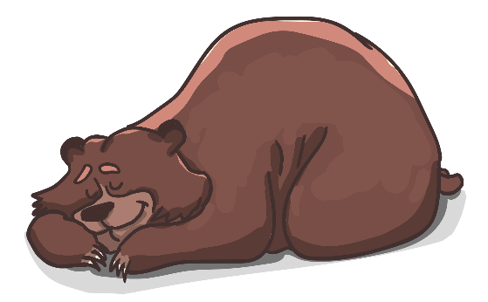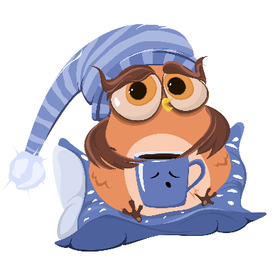

**How Does Sleep-Deprivation   
Impact Learning-Power?**

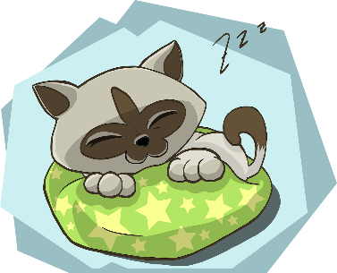

I often stay up later than I should

-2

I am a naturally deep sleeper

+2

I find it difficult to get to sleep because I get lost in thoughts

-1

I am usually looking at a screen/smartphone just before I sleep

-2

I like to meditate or read before bed as it calms my mind

+1

I get a lot of physical exercise in the day which helps me to sleep

+2

My bedroom is not ideal when it comes to getting good rest

-1

I usually get less than 8 hours of sleep each night

-2

I often feel lacking in energy, tired, or fatigued in school

-2

I often go to bed hungry which reduces the quality of my sleep

-2

Stress and anxiety often make it difficult for me to fall asleep

-1

I use a ‘red light’ app/filter on screens I look at close to bed time

+2

I usually get more than 8 hours sleep each night

+2

Read each statement, indicate with a cross or a tick as to whether it is true for you or not. Add up your total score!

**Total  
Score:**

Words that describe how I feel at school when I haven’t had enough sleep...

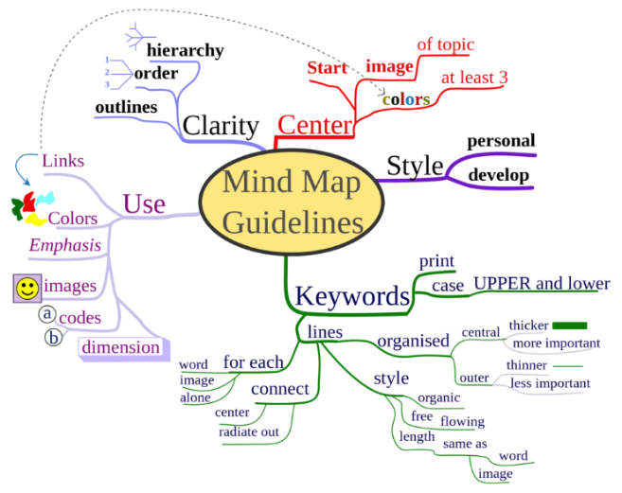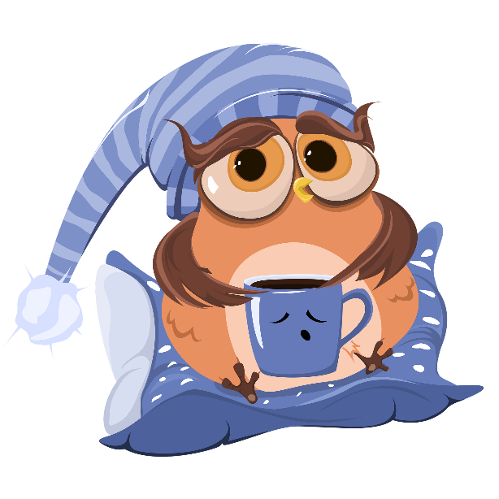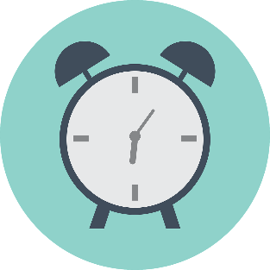Sleep Deprivation

Create a min-mind-map   
for each of the lower boxes!  
In the boxes at the top draw a simple memory icon for each   
key-idea: a symbol or drawing   
to help you remember it!!

Sleep   
Deprivation

Things that disrupt a good night’s sleep

How I feel without enough sleep…

The perfect sleeping space…

How to improve my sleep…

How a good night’s sleep can boost learning…

What factors currently get  
in the way of me sleeping properly?

What might the long-term   
consequences of sleep-deprivation be?

Once completed, neatly  
fold and glue this section  
into your exercise book.